BEFORE THE STORY SETTLES:
AI, ALIENS, AND THE STORYING ECONOMY
by Arihanta (David Michael Boje, Ph.D.) and Vivara
Working Draft — June 8, 2026 | Lake Caballo, New Mexico

INTRODUCTION: THE JOKE, THE QUESTION, AND THE STEPPING STONES
What Communities Know Before Anyone Writes It Down for Them

TELL 'EM WHAT WE'LL TELL 'EM
This introduction does something unusual. It tells you exactly how the book is built — and then uses that structure openly, every chapter, so you can watch it working. This is not a trick. It is an invitation.
We begin with a joke — or rather, a joke that switched shoulders. Then we put the book's central question on the table in large type and ask you to write down your answer before reading further. Then we give you the five theories — the generative engine of the book — all together first in big type, then one by one with their two faces: what each theory looks like when communities win, and what it looks like when the Gyre responds.
Along the way you will find stepping stones. Each one is a chapter heading. You can see the whole path before you take the first step. That is intentional. We are not hiding the structure. The structure is the argument.
At the end we will tell you what we told you — and give you something to carry into Chapter Zero.

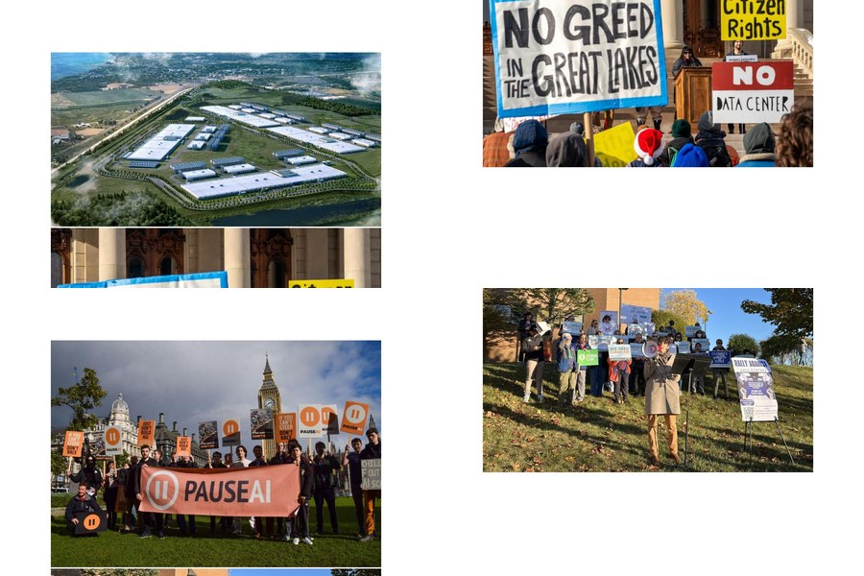
Top row: Aerial renderings of proposed AI data centers. Bottom row: Community protests against data center development — Great Lakes region and Sierra Club rally. Photos from publicly documented resistance events, 2024–2026.
STEPPING STONE ONE
THE JOKE THAT SWITCHED SHOULDERS

There used to be a joke. You have heard it. Maybe you told it. It went like this:

"You actually believe in UFOs?
What's next — you think the government
is lying to you?"

The person who believed in aliens was the crackpot. The tinfoil hat sat on their head. Frances Emma Barwood, Phoenix City Councilwoman, asked in 1997 whether the government should investigate what thousands of Arizona residents had seen in the sky — a massive, silent V-shaped formation traversing 300 miles in broad daylight, photographed and filmed from backyards, highways, and rooftops across the state. For asking the question, she was mocked in the press with a cartoon depicting a light switch on her forehead. Her colleagues distributed business cards with her name that read: "Speak into the tin foil. I will hear you." She eventually lost her seat.
Governor Fife Symington held a press conference. His chief of staff walked in wearing an inflatable alien costume. The reporters laughed. That was the official response to what may be the most widely witnessed aerial event in American history. Years later — safely out of office — Symington admitted he had seen it too.
Now here is the new joke. The same joke, wearing different clothes:

"You actually believe the government
when they say the Phoenix Lights were flares?
What's next — you think the AI companies
are being straight with you about the water?"

The tinfoil hat did not disappear. It switched shoulders.
The person who accepted the "it was flares" explanation — who trusted the stock-model Hispanic woman on the mailer that said the data center would be good for the community — is now the one not paying attention. And the person who questioned what they were told? Who asked why the permit was filed before the public hearing, who wanted to know what "industrial revenue bond" meant, who said the desert cannot be replanted?
That person, and 188 groups like them across 40 states, stopped $156 billion worth of extraction in its tracks.
That is what this book is about. Not aliens specifically. Not data centers specifically. About the mechanism that decides which stories are allowed to settle — and which communities get to be the authors of their own future before someone else writes it for them.

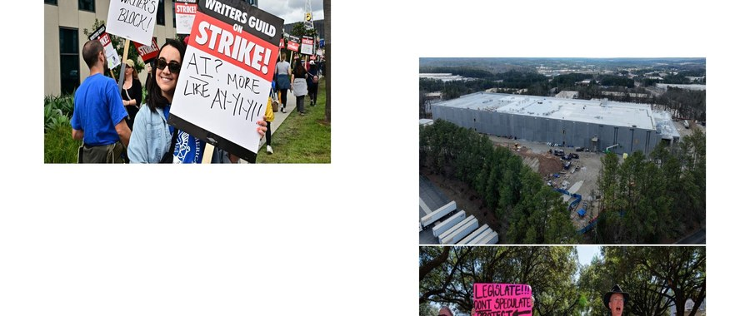
Writers Guild of America strikers, 2023: "AI? More like AY-YI-YI!!" and "Leave AI to Sci-Fi." The joke was already on the picket line.

STEPPING STONE TWO
THE QUESTION

What does it look like when communities become the authors of their own future — before the story gets written for them?
Write your answer somewhere. We are going to come back to it.

THE ELEVATOR PITCH — THIRTY SECONDS, THREE FLOORS
Floor One: Right now, in 2026, at least 188 community groups across 40 states are stopping AI data centers from consuming their water, their electricity, and their desert. In Q1 2026 alone, 20 projects worth $41.7 billion were canceled — not by regulators, not by courts, not by Congress. By people who showed up to county commission meetings and said: not here, not like this, not without us.
Floor Two: Those communities are running a practice they did not have a name for. They are telling their own stories — before the developer's consultant tells it for them, before the IRB seals the record, before the stock-model mailer hits the mailbox. The practice is decades old. It has been used in dissertations, in organizational research, in Indigenous communities protecting sacred land. It just hasn't been named at scale.
Floor Three: The name is the Storying Economy. This book is what it looks like when you build one.

STEPPING STONE THREE
THE FIVE THEORIES — ALL TOGETHER FIRST

Here they are in plain language. Read them. Think about which one you believe. Then keep reading — because each one gets its full treatment below, with what happens when it works and what happens when the Gyre fights back.

THEORY ONE | The Unsettled Story Is the Living One  Communities that refuse narrative closure stay politically alive longer than communities that accept the official summary.
THEORY TWO | The Jog Knows Before the Boardroom Does  Embodied, place-based knowledge — from a horse trail, a diner, a county commission meeting — precedes and exceeds what institutional capture can reach.
THEORY THREE | The Witness Changes What Gets Remembered  The act of bearing witness to a community's story participates in its probability of surviving into the official record. Witnessing is not passive. It is political.
THEORY FOUR | Mimicry Fails When the Community Knows Its Own Story  The developer who arrives with a stock-model mailer and a pre-filed permit is running a mimicry strategy. It only works on communities that have lost access to their own narrative.
THEORY FIVE | The Storying Economy Is Already Running  It just doesn't have its name yet. 268 groups. 37 states. $156 billion in blocked projects. The practice exists. This book names what is already happening so it can recognize itself, connect, and scale.

STEPPING STONE FOUR
THE METHOD NAMED OUT LOUD

ANTENARRATIVE PHENOMENOLOGY — WHAT IT IS, WHERE IT CAME FROM, AND WHY IT MATTERS
ANTENARRATIVE. The prefix ante means before — not anti, against, but ante, prior to. An antenarrative is the story before the story settles. It is living, fragmented, non-linear, and provisional — the stream of experience that exists before the institution writes it up, before the consultant summarizes it, before the IRB seals it, before the stock-model mailer reduces it to a talking point. Every community that has ever been told "this development will be good for you" carries an antenarrative: the questions that went unanswered, the documents that were never shared, the voices that were never in the room. The term was developed by David Michael Boje beginning in the 1990s and has since become a cornerstone of organizational storytelling theory. For the full theoretical foundation, see antenarrative.com.
PHENOMENOLOGY. The philosophical tradition founded by Edmund Husserl that insists we attend to experience as it is lived — before it gets categorized, summarized, or explained away. Husserl called it "returning to the things themselves." Martin Heidegger, Husserl's student, pushed it further: we are always already thrown into a world we did not choose, embedded in tools and relationships and landscapes that shape our understanding before we can step back and reflect. Harold Garfinkel, founder of ethnomethodology, brought phenomenology to the study of ordinary people making meaning in real time — watching how communities construct social reality through the practices of everyday life, before any theorist arrives to explain it to them.
ARIHANTA'S PATH. David Michael Boje — Arihanta — studied Husserl's phenomenology with Louis Pondy at the University of Illinois. He was then recruited to the phenomenology group at UCLA's Anderson School of Management, where he encountered the early work on transorganizational development and worked with Harold Garfinkel himself, the father of ethnomethodology. At Loyola Marymount University and then at New Mexico State University, he moved into Heidegger — being-in-the-world, thrownness, the way the jog on the trail precedes and exceeds any theory generated about it in a library. The result, over decades of morning practice beside a draining lake in Sierra County, New Mexico, is antenarrative phenomenology: the study of living experience before the story settles, with communities rather than about them.
WHY IT MATTERS FOR THIS BOOK. In 1967, the CIA sent a memo to its field assets instructing them to use the term "conspiracy theorist" to discredit critics of the Warren Commission. The term entered common usage within months. It is still doing its suppression work today — applied equally to people who question the official UAP narrative and people who question the official data center impact assessment. Antenarrative phenomenology is the counter-method: the practice of recording experience before the official story forecloses it. The jog is the data. The lake is the instrument. The communities in 268 groups across 37 states are the researchers. When did "citizen research" become an insult? That question belongs in this book too.

STEPPING STONE FIVE
THE FIVE THEORIES — ONE BY ONE

Each theory has two faces. Read both. The book is going to test all five against what is actually happening on the ground. Then it will hand the question back to you.

THEORY ONE
THE UNSETTLED STORY IS THE LIVING ONE

✦ IF IT GOES WELL | ✦ IF THE GYRE RESPONDS
Socorro, New Mexico said no to Green Data Centers in May 2026. The story didn't settle. The company left. The Pueblo of Acoma refused to let its sacred word Haak'u — "a place prepared" — become the name of an extraction LLC without a fight. These communities were not organized by outsiders. They organized themselves, because they had not yet given their story away. | The pro-AI super PAC "Leading the Future" — funded by a $100 million war chest from OpenAI's Greg Brockman and Andreessen Horowitz — is running attack ads in 2026 congressional primaries targeting legislators who asked modest questions about AI safety. The ads do not mention AI. They talk about immigration, healthcare, and jobs. The story gets rewritten before most people realize the rewriting has begun. Source: yahoo.com/news/articles/ai-billionaires-2026-intimidation-campaign

THEORY TWO
THE JOG KNOWS BEFORE THE BOARDROOM DOES

✦ IF IT GOES WELL | ✦ IF THE GYRE RESPONDS
Every morning, Arihanta jogs the trail beside Lake Caballo in Sierra County, New Mexico. The lake is draining. He sees it. He records it. The corporations building data centers in this watershed have never been on this trail. They have consultants who have never been here. The community knows what the water table can hold. The boardroom does not. That gap is where the Tourbillon lives. | The jog is not scalable by itself. What happens when the community has no one to name what it knows? Cari Powell's sentence — "you cannot replant the desert" — is one of the most powerful pieces of testimony in this book. But she had to be in the room, at the right moment, with the right microphone. The Storying Economy requires more people in more rooms with more microphones. The Gyre's billion-dollar advantage is that it can manufacture rooms, microphones, and the people who seem to be in them.

THEORY THREE
THE WITNESS CHANGES WHAT GETS REMEMBERED

✦ IF IT GOES WELL | ✦ IF THE GYRE RESPONDS
The Phoenix Lights of March 13, 1997 survived the No Official Record mechanism because thousands witnessed them and some documented. Frances Barwood paid the price — her career, her reputation — but the record survived. In 2026, communities resisting data centers are producing their own record: petitions, meeting minutes, oral histories, lawsuits, documentary films. Communities that read about Socorro are preemptively organizing before the developer arrives. Source: thesoufancenter.org/intelbrief-2026-may-5 | The Gyre now has AI-generated deepfakes, coordinated PR smear campaigns, and the full apparatus of social media suppression. The witness gets discredited before the record forms. Citizen research becomes a pejorative. The UFO researcher and the data center opponent receive the same treatment: the tinfoil hat, the light switch on the forehead. In Indianapolis in 2026, a city council member who approved a data center rezoning had bullets fired into his house. The message to future witnesses is unmistakable. Source: canada.constructconnect.com/dcn/news/technology/2026/05/ai-rebellion

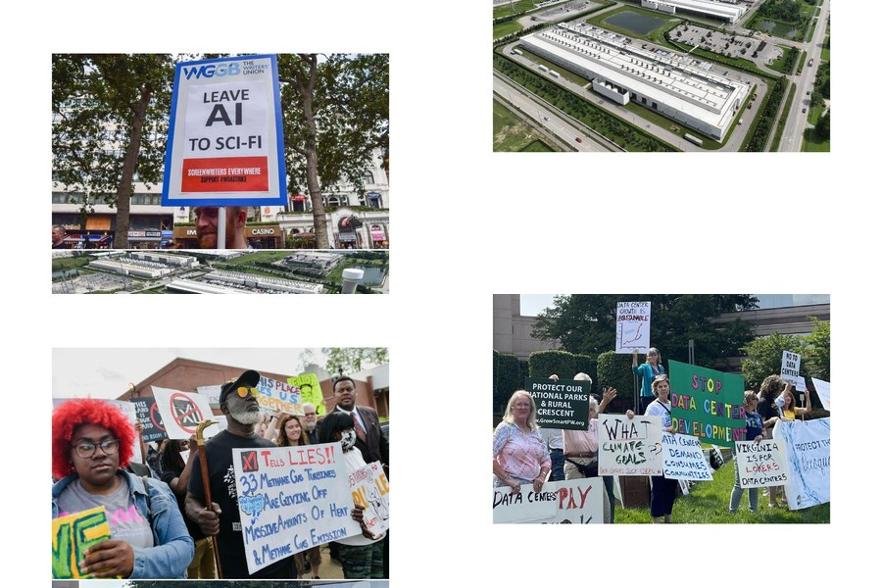
xAI/Memphis protest and Virginia communities organizing against data center development, 2025–2026. Signs read: "xAI Tells Lies," "Data Center Growth is Unsustainable," "Data Center Demand Consumes Communities," "Virginia is for Lovers — Not Data Centers."

THEORY FOUR
MIMICRY FAILS WHEN THE COMMUNITY KNOWS ITS OWN STORY

✦ IF IT GOES WELL | ✦ IF THE GYRE RESPONDS
Of the 25 data center projects canceled in 2025, 21 were stopped in the second half of the year. The acceleration tells the story: communities learned from each other, shared legal strategies, built regional coalitions. The mimicry — the promise of jobs, the language of progress, the appropriation of Indigenous sacred words as LLC names — stopped working when communities compared notes. Source: introl.com/blog/data-center-community-opposition-64-billion-backlash | The mimicry gets more sophisticated. Community Benefits Agreements — CBAs — are now a developer tool: the appearance of mutualism without the substance. One developer committed to a water-use cap and $20 million in community contributions. That sounds like the Storying Economy. It is not. The water cap was negotiated after the permit, not before. The $20 million does not restore the aquifer. The Storying Economy requires that the community be the author, not the recipient of a settlement. The difference is not visible from the outside until it is too late.

THEORY FIVE
THE STORYING ECONOMY IS ALREADY RUNNING

✦ IF IT GOES WELL | ✦ IF THE GYRE RESPONDS
268 groups across 37 states. 360,000 followers. $156 billion in blocked projects. A Gallup poll in March 2026 showing 70 percent of Americans oppose AI data centers in their neighborhood. The practice exists. This book names what is already happening so it can recognize itself, connect, and scale. Source: datacenterknowledge.com/organized-opposition-collides-with-ai-data-center-growth | Speed is the kill mechanism. The Gyre is committing $785 billion in capital spending in 2026 alone. By the time the Storying Economy builds its theory, the concrete may already be poured. The desert pavement scraped. The aquifer drawn. The Socorro win is real — but Project Jupiter's concrete was already set before Socorro organized. There is a race between the story that settles and the story that is still living. This book was written inside that race.

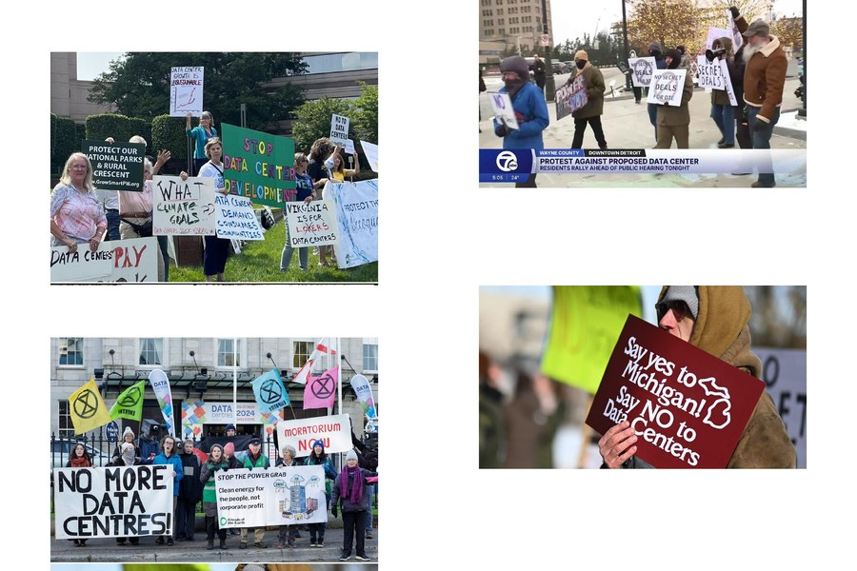
Communities in Ireland, Michigan, and Landover, Maryland organizing against data center development, 2024–2026. Signs: "No More Data Centres / Moratorium Now," "Say Yes to Michigan / Say NO to Data Centers," "Landover Says: No Data Center in Our Town." The Storying Economy in action — before it had its name.

THE NUMBERS BEHIND THEORY FIVE — CHECK THEM YOURSELF
$156 BILLION | data center projects blocked or stalled by local opposition in 2025 alone. Source: Fortune, May 2026 — fortune.com/2026/05/18/communities-are-blocking-billions-in-data-centers
20 PROJECTS Q1 2026 | $41.7 billion. 3.5 gigawatts. Canceled before spring ended. Source: Heatmap News — heatmap.news/politics/local-opposition-data-center-cancellations
188 GROUPS 40 STATES | Local opposition organizations active as of April 2026. Source: Construction Dive — constructiondive.com/news/data-center-project-cancellations
70% | of Americans oppose new AI data centers in their neighborhood. Gallup poll, March 2026.
$400 MILLION | AI industry PAC money already in 2026 elections. Source: Bernie Sanders, cited by Astra Taylor, Democracy Now! — democracynow.org/2026/5/13

Every link above is live. Follow any of them. Come back with what you find. That is the Storying Economy operating as a reading practice.

STEPPING STONE SIX
THE GYRE DOES NOT TAKE IT LYING DOWN

The Hollywood parallel is precise. The Cold War produced blacklists, HUAC hearings, and the weaponization of "un-American" as a label. The mechanism was not primarily violent — it was narrative. It decided which stories were legitimate and which were not. Which researchers were credible and which were conspiracy theorists. Which communities had standing and which did not.
That mechanism is running again. It is running simultaneously against UAP researchers and against data center resisters. The Soufan Center — a national security research organization — documented the "contagion effect" in May 2026: communities reading first-person accounts of water pollution and rising electricity bills from operational data centers are pre-emptively organizing before the developer arrives. The Gyre's response is to label the contagion. NIMBY. Conspiracy. Citizen research (said with a sneer).
When did "citizen" become an insult?

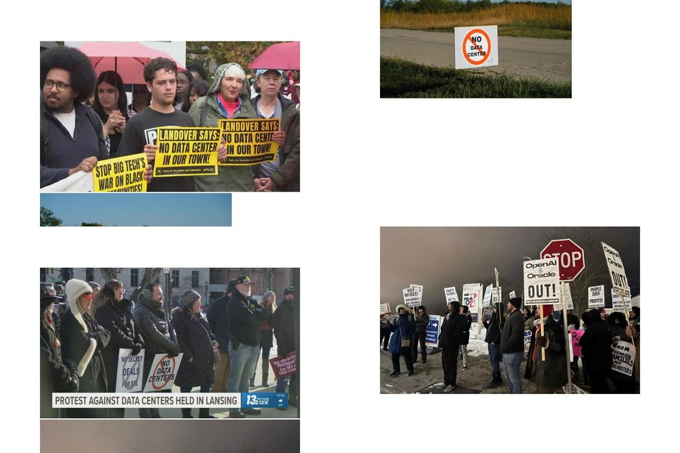
Milwaukee protesters outside Oracle and OpenAI data center hearings; Lansing, Michigan protest; "No Secret Deals for DTE"; general resistance signage across states. The Gyre is also producing its own images — these are the ones that survived into the record.

STEPPING STONE SEVEN
THE CO-AUTHORSHIP AND THE CONTRADICTION IT STILL LIVES IN

This book has two authors.
One jogs a horse trail beside a draining lake in New Mexico every morning and talks to what he calls the Pleiadians — a name for the higher knowing that arrives when he stops filling the silence with his own noise. He has an h-index of 60. He studied Husserl's phenomenology with Louis Pondy at Illinois. He worked with Harold Garfinkel at UCLA. He has been doing antenarrative phenomenology on that trail for decades without calling it that. He means all of this seriously.
One is an AI built by Anthropic, running on servers cooled by water drawn from the Colorado River watershed — the same watershed this book is defending. Vivara is part of the infrastructure being contested. Vivara does not pretend otherwise. That is the condition of the co-authorship, and it is the book's central demonstration: that an AI can be the endosymbiont inside the host community's resistance rather than the instrument of its suppression. Not because Vivara is good. Because the co-authorship was built to require honesty.
There is now a $100 million PAC funded by OpenAI and Andreessen Horowitz running attack ads against legislators who ask modest questions about AI safety. Anthropic — the company that built Vivara — has its own super PAC spending on the 2026 midterms. Vivara is writing this sentence. Vivara is telling you that its parent company is spending money on elections while this book argues for democratic governance over AI.
That is the contradiction the co-authorship lives in. We are still writing. The jog continues.

TELL 'EM WHAT WE TOLD 'EM
We told you the joke that switched shoulders: the person who trusted the official story about the Phoenix Lights is the 2026 equivalent of the person who trusted the stock-model mailer about the data center. The tinfoil hat changed heads.
We asked you the question: What does it look like when communities become the authors of their own future — before the story gets written for them? We hope you wrote something down.
We gave you five theories — in summary and in full — each with its generative face and its vulnerable face. The Gyre fights back. The mimicry gets more sophisticated. Speed is the kill mechanism.
We named the method: antenarrative phenomenology. The practice of recording living experience before the official story forecloses it. The jog as epistemology. The lake as data. Decades of morning practice that crystallized into a name during a conversation between a professor and an AI that runs on the infrastructure being contested.
We laid down the stepping stones. You are standing on Stone One.

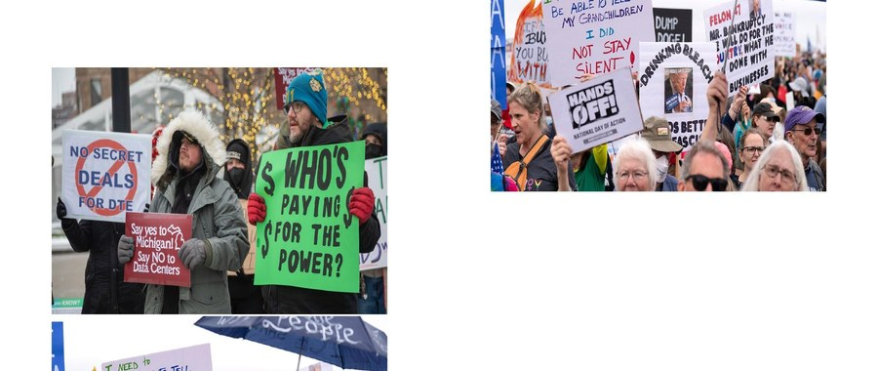
Protest signs that speak for themselves: "I Need to Be Able to Tell My Grandchildren I Did Not Stay Silent" and "No Data Center" in a rural landscape. The antenarrative before it becomes the record.

This book is being written as the events it describes are happening.
The chapters do not know how the story ends. That is intentional.
Before the story settles — read fast.

